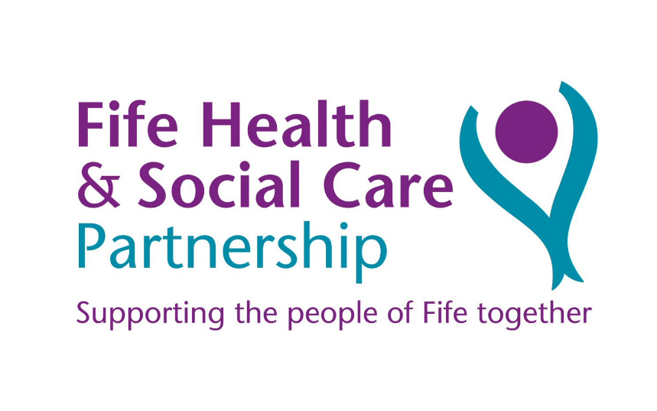

Fife Health and Social Care

Digital Strategy 2023 – 2026

Engagement Report

|  |  |
| --- | --- |
| Authors | Tatiana Zorina  Ewan Heeles  Participation and Engagement Team |
| Date | 18 September 2023 |

**Table of Contents**

Executive Summary 3

Introduction 4

The Engagement Timeline 5

Stakeholder Engagement 6

Designing the engagement 6

Engagement methods 6

Public engagement 6

Who did we engage with? 7

Staff consultation 8

Engagement feedback 9

Public Engagement 9

Local 9

Integration 10

Outcomes 10

Wellbeing 11

Sustainable 11

We asked, you said, we did 12

Staff Engagement 13

Local 13

Integration 14

Outcomes 15

Wellbeing 17

Sustainable 17

Heads of Service Feedback 20

We asked, you said we did 21

Final consultation comments 22

Conclusion 23

Appendices 24

Appendix 1 Engagement Map 24

Appendix 2 Stories 25

# **Executive Summary**

The Fife Health and Social Care Partnership’s Participation and Engagement Team supported the Digital Strategy Working group from April 2023 to September 2023 to plan, develop and deliver an engagement activity to support the development of the first ever Digital Strategy for the Fife Health and Social Care Partnership (Fife HSCP).

Most of the public engagement activity has taken place face to face, however members of the public also had the opportunity to respond to questions asked online, with the QR code and a link to the questions being shared with as many people as possible.

Public engagement has taken place at all seven Fife Localities (Appendix 1). Stakeholders were able to give their views in GP surgeries, supermarkets, in both adult and young carer groups, at coffee mornings and a City Conference. As a result, we have gathered the views of 188 people. Most of the engagement took place over the summer school holidays, which proved to be a barrier in reaching some of the existing groups.

Due to the time constrains it was decided to carry out the staff consultation online via MS Forms, which received 368 responses.

Throughout this consultation it was evident that people are keen to support digital, however they would require appropriate training and support to use modern and innovative technology. Although there is evident support in general towards “the digital world”, most of the people we have spoken to highlight the importance of “human contact”. Those who engaged in the consultation spoke about the importance of having a choice, for example GP appointments could be offered face to face, online or over the phone; where service users are able to make a choice of the way they interact with their GP and wider health and social care services. Having more resources available online would be supported by both the public and staff working within Fife.

“I think digital support needs to be balanced with face-to-face interactions. Connection is what keeps us well.”

“As a minimum please can we have self-booking for appointments.”

“Knowledge is power, to ensure services are delivered in a more streamlined and faster efficient manner technologies can be used to ensure this.”

Fife Health and Social Care Partnership would like to thank everyone who has responded to this consultation for their time, and for sharing their views on the draft of the Commissioning strategy 2023 – 2026.

# **Introduction**

Fife Health and Social Care Partnership is on a journey to develop its first Digital Strategy 2023-2026. The working group decided the development of the strategy would be best supported if engagement took place with staff working for the Partnership, as well as our service users and public.

The objective of the consultation was to not only “go back to basics” and find out what word “digital” meant for people but also gather what is important, what currently works and what does not.

Although Fife Council and NHS Fife have digital strategies in place, Fife Health and Social Care Partnership did not. Having our own digital strategy is an important step for the Partnership, as we believe it will help us transform and enhance the services we deliver.

This report is a summary of the feedback that has been received from both public and staff consultations. A substantial amount of feedback has been gathered during the process, all comments received during the consultation period have been themed into the strategic priorities of the partnership: local, wellbeing, integration, outcomes and sustainable.

Prior to starting this engagement activity, the team was aware of possible “consultation fatigue” and that people are “getting fed up” with completing numerous online forms. The decision was made to engage with public face to face to help further our understanding of what is important from their perspective. Members of the public were very keen to speak to us and to share their views, while a few people commented on the importance of taking public views into consideration when writing a brand-new strategy.

The feedback from both public and staff will influence the design of the Draft of the Digital Strategy 2023 – 2026.

# **The Engagement Timeline**

Public Engagement has taken place over 3 months, from June to August 2023, both face to face and online.

Staff consultation has taken place online via MS Forms and was open for 4.5 weeks.

The Engagement Timeline below includes the engagement that has taken place so far, as well as planned engagement around the draft of the Digital Strategy 2023-26, once its approved for the public consultation.

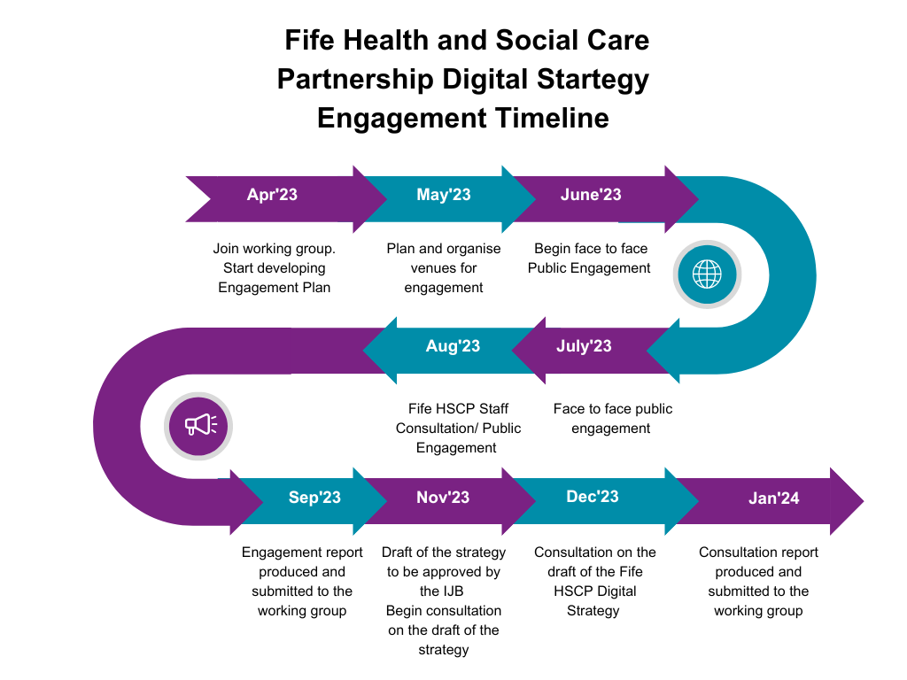Pic 1

# **Stakeholder Engagement**

## **Designing the engagement**

A short time working group was created to design the questions for the public consultation. Final version of the questions was approved during the working group meeting on 14 June 2023.

The same questions were used for the staff consultation with added questions around team digital priorities.

## **Engagement methods**

### **Public engagement**

Public engagement has been completed throughout Fife through a variety of methods.

These include:

* + Facebook Engagement – 5 days of targeted questions on the HSPC Facebook page.
  + Visiting GP surgeries speaking to patients
  + Attending public events including coffee mornings, City of Dunfermline launch, Kirkcaldy Open Day
  + Attending organised groups including The Stand, Fife Carers, Fife Young Carers, Change Mental Health
  + Attending Care Homes
  + Stalls at supermarkets
  + Survey posted on Fife Carers Facebook page with specific questions for carers.

Opportunities for a 1 to 1 meeting was offered should anyone wish to either expand on their thoughts, had a genuine interest in the subject or some experience that they wished to share with the team.

## **Who did we engage with?**

Public engagement took place across all 7 Fife localities. Most engagement was in the form of face-to-face discussions. We have spoken to staff and residents in care homes; service users at various GP surgeries; members of groups we visited including carers groups, lunch clubs and a city conference; and members of the public at a stand in a local supermarket. We also engaged with several Fife residents on a one-to-one basis to hear their stories about what digital experiences they have had with Fife HSCP. The map below highlights the geographical scope of this engagement exercise.

**Who did we engage with (public)?**

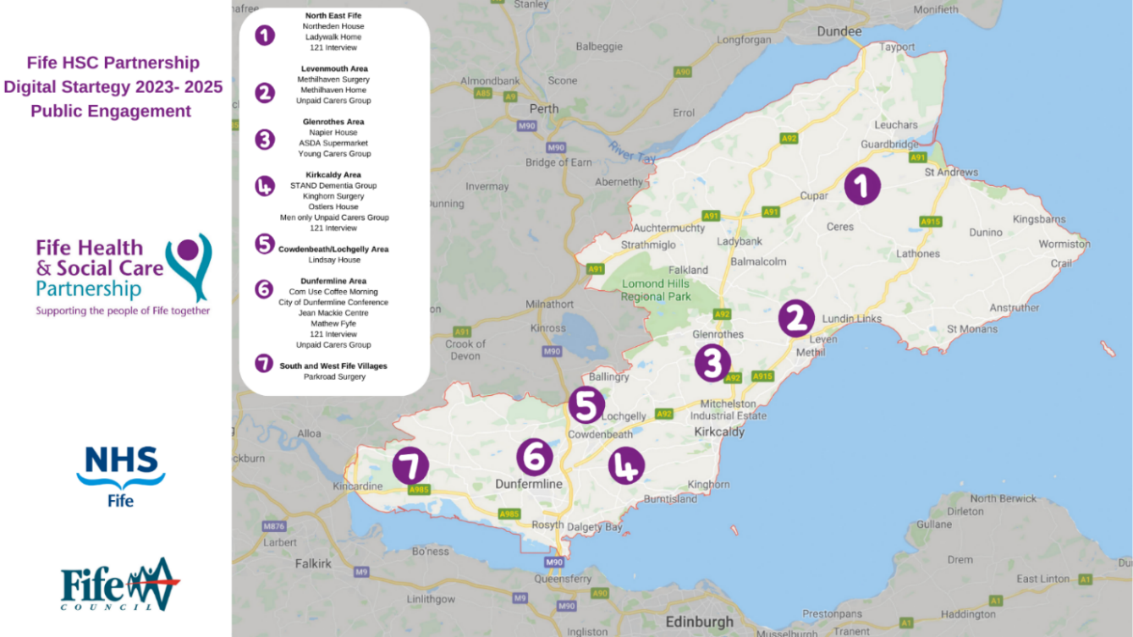 Pic 2 (also in Appendix 1)

### **Staff consultation**

Staff consultation was on hold due to an ongoing digital maturity assessment, however later it was agreed that the staff consultation should take place. Due to time constraints, it was been decided to use the online platform MS Forms to seek staff feedback. The consultation was open for just over 4 weeks, and was shared widely, receiving 368 responses in total.

The Staff consultation received 368 responses with over 2500 comments, 12 Heads of Service replied to the consultation.

Pic 3 Digital Strategy, Staff consultation. Q. Which of the following best describes you?

# **Engagement feedback**

## **Public Engagement**

A significant amount of feedback was gathered during the public consultation. It has been broken down into five themes to mirror the Strategic Priorities within Fife HSPC’s Strategic Plan for 2022-25. These are:

* Local
* Integration
* Outcomes
* Wellbeing
* Sustainable.

### **Local**

*“A fife where we will enable people and communities to thrive.”*

Eight Care Homes were visited during the public consultation to influence the development of Digital Strategy 2023-26. It was very apparent that most residents and staff at our care homes feel digitally disconnected from the world, which is contributing to a sense of social isolation and loneliness. 87.5% of care homes didn’t have a Wi-Fi connection, in the remainder, access to the internet was very poor.

Sandra has shared her story (Appendix 2), showcasing how her life has changed when she moved to a care home. She now receives excellent care to support her physical wellbeing, however her mental wellbeing is being affected due to lack of Wi-Fi facilities at the care home she lives in. Unfortunately, Sandra isn’t alone and there are many similar stories where residents aren’t able to stay in touch with their family and friends as easily and/or as often as they wish to. Another resident of the care home was awaiting discharge as we were speaking to him and his main reason for wanting to go home was access to a computer and a Wi-Fi; he said that his stay at care home would have been a lot more pleasant should he have had access to technology.

Some care homes currently have iPads that residents can use to speak to their families on “FaceTime”. However, because this resource is kept in a staff room and use has to be supported by a staff member, family members are required to make an appointment to speak to their family member who resides at the care home which causes time delays in communication and reduces residents’ independence.

Not Being able to download books on Kindle was another issue highlighted by the residents.

The Jean Mackie Centre have smart TVs in residents’ rooms; however, the ‘smart’ function is not available for use due to the lack of Wi-Fi. One care home resident said that *“In 20 years there will be more people used to digital technology as people are growing up with it now so the homes will need to have it”*, staff member replied: *“Having more technology would improve life in the care home for residents.”*

### **Integration**

*“A fife where we will strengthen collaboration and encourage continuous improvement.”*

A significant number of members of the public have talked about streamlined processes and “easier” access to doctors and other appointments, saying that it should be a similar system to booking a table at a restaurant. “It would be great to go on app and see what appointments are available and book.” The app could have options of online, face to face, or telephone appointment, with a space to say why you require an appointment.

Another system was mentioned where patients can send a photo to a doctor surgery and if the issue can be dealt with online or over the phone, noting this would save a lot of time for both – staff, working within service and public.

The majority of people were complementary about the online services and online doctors’ appointments they were able to access during Covid-19 Pandemic, stating that in some doctor surgeries this has now stopped. Although not suggesting that the services should move online, the majority were highlighting the choice that service users could have while accessing services.

*“Would be great to have online GP appointments where appropriate, not always need to see a doctor face to face; especially if it’s just to discuss change of medication etc.”* – care home staff member.

*“Booking system for the GPs and doctors would really enhance the service. A service where I can see the calendar and can book myself to an available spot. An app would be a great solution; it can be very easy and straightforward.”* Male, Age 19

A significant number of members of the public also highlighted experience of repeating their ‘story’ many times, suggesting that better communication systems should be available within the Health and Social Care Sector to resolve this issue.

### **Outcomes**

*“A Fife where we will promote dignity, equality, and independence.”*

During care home visits, staff were involved in discussions and in agreement with residents, that access to Wi-Fi and modern technology could lead to them having a more ‘normal life’, similar to what they have experienced when living in their own community. It would allow more opportunities and resources to open up to residents which might lead to a better quality of life, boost their independence and sense of freedom and connection. These could include:

* Access to digital content including visual and audio on an individual and group basis – encouraging socialising during possible movie nights and music evenings;
* Virtual connections to friends and family in addition to face-to-face visits;
* Virtual connections to other groups in the community including Care Homes;
* Virtual connection to online activities and events such as Exercise classes;
* Artificial intelligence such as ‘Alexa’ service being available in rooms for residents. Giving access to knowing the time and setting reminders; and taking advantage of features such as streaming the radio or listening to audiobooks.

Both staff and residents at the care homes highlighted the lack of training and support. Some residents do have their own technology however are losing the knowledge via lack of use and said it would be beneficial to have refresher sessions around how to set up and use technology they already have.

While speaking to a group of carers it has been highlighted that it would be beneficial to have access to funding information, where carers can apply for funding to be used towards buying technology that would improve their caring responsibilities.

Indoor CCTV systems were mentioned as an alternative to a paid carer, allowing unpaid carers to have some free time from their caring responsibilities. This was an example given by one carer, who shared that she is using the ‘Blink system’ through-out her house, allowing her to go out but still keep an eye on her husband.

*“I currently use my mobile phone to keep in touch with the person I care for and family, order medication and do my online shopping.”* Unpaid Carer

### **Wellbeing**

*“A fife where we will support early intervention and prevention.”*

While discussing early prevention and intervention with members of the public and service users; the majority have commented on a lack of trusted information being available on the internet; or perhaps an awareness of determining which information is correct and reliable, and which is not. We asked the public: thinking of Prevention and Early Intervention; how can technology improve your experience?

*“Access to information and services without having to leave home.”* Service user

“Finding out symptoms or red flags that encourage us to seek advice.” Service user

The use of appropriate equipment and the necessary training was also mentioned as something that would allow people to stay in their own homes longer.

There was a suggestion from a staff member working in care home, that availability of Wi-Fi would support an overall wellbeing of those living in care home and their family:

“Personally, I feel that families would spend more time within the home with loved ones if technology was improved. For example, putting on a film in the cinema room, the kids would want to watch it and spend more time, instead of the families ‘dropping’ in.”

Care home staff member

A group of carers suggested that joint training where carers and patients learned together would improve relationships and would make a challenging a lot easier. They said: this would allow us to learn together, and would not only help the relationship, but would also allow us to remind each other of what we had learned.

### **Sustainable**

*A Fife where we will ensure services are inclusive and viable.*

In terms of sustainability members of the public have raised concerns around the longevity of the applications, websites, and other digital solutions. Although public is keen to go digital, they suggested that there needs to be more support and advice available regarding use of the suggested digital solutions. One public member said: “I am happy to download an app where I can look up an info or book appointments, but I need to know it will not be out of date tomorrow and that I will not need to download updates everyday”.

## **We asked, you said, we did**

Having read through the public engagement feedback within the report, it is clear that there are priority themes which we (the Fife HSC Partnership) must include in our recommended delivery plan within the Digital Strategy.

These themes are:

* Wi-Fi in care homes
* enhancing digital inclusion;
* improving mental health and welfare of residents.
  + bookable appointments online
* improving access to services.
  + increased use of monitoring and sensor technology
* enabling people to live independently at home for longer;
* enabling prevention and early intervention of health conditions, falls and hospital admissions.
  + easily accessible access to information online
* supporting people to self-help thus reducing referrals.

# **Staff Engagement**

Staff engagement has been broken down under the same themes to allow a clear analysis to be made, and overall themes to be identified. 368 staff replied to the consultation with over 2500 comments made.

### **Local**

*“A fife where we will enable people and communities to thrive.”*

Staff were first asked to describe what the word digital meant to them (pic 4). 69% said that it meant being connected and using technology. One summarised it as “Connecting and information sharing with others via an online or commuter-based platform”, and another stated “[digital] allows for better collaboration with colleagues and brings people together”.

A lot of positive comments were made towards digital connection and the benefits the introduction of MS Teams has brought; with teams now able to interact with wider teams, helping to avoid social isolation. In contrast, however, some have highlighted the importance of face-to-face interactions.

Pic 4 Digital Strategy, Staff consultation. Q. In this modern world, what does DIGITAL mean to you?

### **Integration**

“*A fife where we will strengthen collaboration and encourage continuous improvement.”*

We asked staff what digital solution could improve their work? An overwhelming majority of 41% of staff said that they need to have increased access and removed barriers. A lot of comments were made in relation to the potential merge of Fife NHS and Fife Council systems.

Pic 5 Digital Strategy, Staff consultation. Q. What digital solutions could improve the way you work?

“NHS and Council staff having either access to both intranets, or developing a HSCP Intranet for staff. Integrated IT systems to minimise the amount of time a patient has to tell "their story".

“I work in Fife Health and Social Care Service on the local authority side. I am continually frustrated that the information systems between health and social care are not accessible to all. My colleagues in health do get access to the Social Work system but staff working in Social Care do not get access to any health patient information systems which is not equitable between services. From Social Work we have to write to the GP which bears a cost as we are charged for this information!”

“The fact that none of the electronic patient data / activity clinical notes etc systems speak to each other and this then leads to double reporting / time consuming workload.”

Over a quarter (25.7%) of responses were in relation to improvement of communication process, covering both internal communication with staff (16.7%) and external communication with service users (9%). In terms of internal communications, comments were similar to the above with staff stating that systems are not joined and sometimes staff struggle to get in touch with each other if they are either an NHS or Council employee. There were several comments saying that although MORSE is a great tool, it requires an update and “a bit of tweaking”. The new Patient Hub has been highlighted as a good example of a communication tool being used with Service Users. A text messaging service was suggested as a potential service for communication with the public and video resources with accessibility for children and young people has been highlighted as having the potential to improve service and avoid repeat of information, as well reducing the need for face-to-face appointments.

We then asked staff how digital solutions can support current processes (pic 6). Most people highlighted the importance of information sharing between the services and the need to improve our services. In a lot of cases, staff were talking about integration and integration of services, as per the previous question, one of the standout suggestions was for Fife Councils and NHS Fife computer systems be compatible, with several staff noting the frustration to this not being the case.

In terms of sharing information this included:

* Linking the Fife Council and NHS systems.
* Combining health care and social care notes (one database).
* Having access to all applications and having selected ones identified across the service.
* Better links between primary and secondary care service.
* One universal system to make the patients journey much easier.

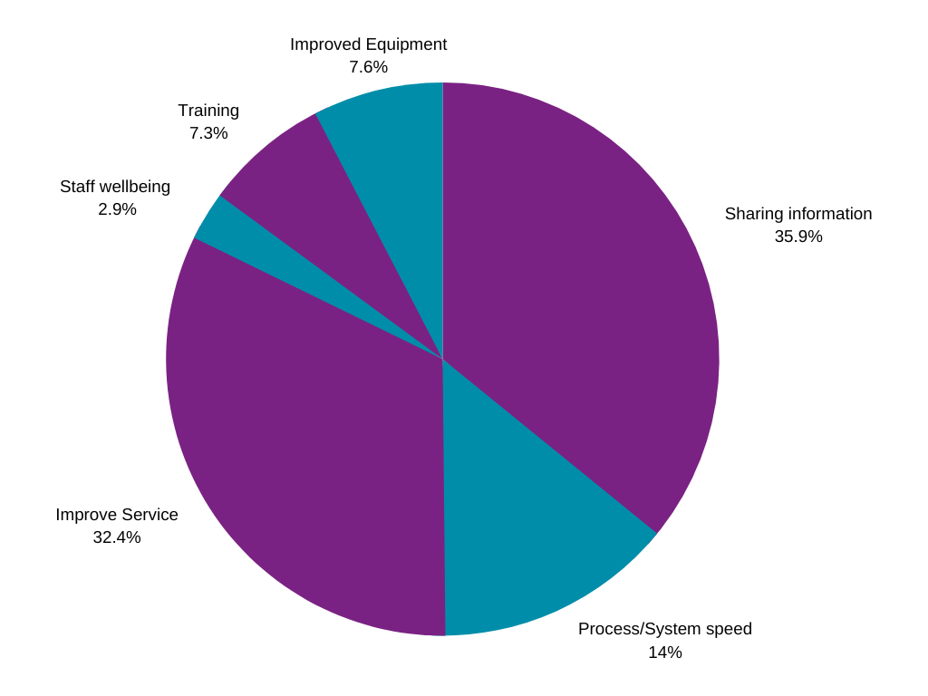

Pic 6 Digital Strategy, Staff consultation. Q. How can digital solutions support current process?

### **Outcomes**

*“A Fife where we will promote dignity, equality, and independence.”*

Almost half of the respondents (41.2%) highlighted that training is very important in supporting the digital awareness of staff. Many people highlighted that there needs to be more allocated time for staff to be able to do the necessary training, as there isn’t the time necessary within their working day to complete training and understand what systems are available and how to use them. Along with the training, almost 16% of staff said that they need more support and reassurance in using technology and digital solutions.

Pic 7 Digital Strategy, Staff consultation. Q. How can we support your digital awareness?

“Give time in the working day to be trained/refresher. Have a person on hand to ask a question or be shown how to...”

“Provide training near to the time of a new system going live - often given months in advance and then forgotten what to do when it starts. Provide backup support when new systems introduced.”

A member of staff who currently work at our care homes, highlighted paper still being the main resource they use for taking notes, issuing medications, write observations and take food orders. The majority said that handheld devices would allow them to be more efficient in their work.

“Wish there was Wi-Fi at the care home and handheld devices so we can record mars charts online, saving time and avoiding loss of data and mistakes. Currently everything must be done on paper and then transferred onto the system in the office. Similar with care plans, currently all done on paper and then require going into the office and type up, so double work. Admin takes a lot of staff time, taking away time we can spend with residents.”

The potential of new systems improving efficiency was highlighted in particular, by one care home staff member, who was very enthusiastic about the new system that had just been introduced at their care home saying:

*“Recently, the kitchen food auditing system moved to a digital platform. Many staff hours have been saved due to not having to manually check each item and submitting paper recording request forms. The click of a button has also allowed the kitchen staff to spend more to speaking and engaging with residents.”* Staff member, Lindsay House

### **Wellbeing**

*“A fife where we will support early intervention and prevention.”*

When talking about wellbeing – staff mainly highlighted the need to have a balance and the time necessary to take a break from the screen. Here are some quotes from the staff survey:

* *“We need digital solutions that allow inclusivity so if you have a disability, you can still engage and participate eg electric wheelchair, voice activated technology, switches for cause and effect.”*
* *“Remembering how each system works, particularly ones I don't use regularly. Also spending too much time on a screen or having emails/messages constantly coming in can be really overwhelming. I need time away from technology to function well at work.”*
* *“It is difficult to release clinical time from staff to facilitate learning and implementing digital and new technology due to competing demands on staff, eg. waiting lists.”*
* *“The reliance on them (digital solutions) has made working smarter but at the cost of staff mental health. There needs to be limits on time spent on teams on emails and an understanding that staff are not constantly sitting at their desks to be contacted via teams/emails.”*
* *Many of our staff and patients lack confidence in the use of digital technologies and services. This can lead to ineffective or non-optimal use and in some instances complete avoidance. With appropriate training we could support more patients to support themselves.*

### **Sustainable**

*“A Fife where we will ensure services are inclusive and viable.”*

A third of the staff who took part in the consultation have highlighted specific systems that currently work well, allowing staff to be efficient in their work. The following have been mentioned:

* MORSE
* Microsoft: Outlook, Calendar, Teams, Planner, Notes, Forms
* Near Me

“Our service has recently moved to MORSE system for electronic notes, we are an MDT service, and this system is a valuable way to ensure the most up to date communication across the whole team to ensure continuity in patient care. We also use several digital rehabilitation resources that support neuro rehabilitation of in-patients and out-patients to increase independence and reduce long-term disability. Near Me has allowed the opportunity for patients to have a choice of where they receive their rehabilitation - this is particularly beneficial to those in rural locations or those that cannot travel due to their health condition. It also reduces need for staff travel and makes review appointments more time efficient.”

Remote working and flexibility have been highlighted as a positive by almost 20% of staff.

Pic 8 Digital Strategy, Staff consultation. Q. Thinking about all things DIGITAL and the way you work, what currently works well for you?

There was a significant number of comments throughout the consultation that communication has hugely improved with the digitalised way of working; this includes communication within teams and with the service users. Almost 7% of staff think that new way of working and access to digital solutions have improved Service User experience, as people now have more choice on how they receive the service.

An option to store valuable documents online was also mentioned by a significant number of staff and highlighted as important.

“Having files saved online rather than paper files - easier to access when not based within the office.”

Staff were also asked: In terms of DIGITAL, what is important to you while you work?

Pic 9 Digital Strategy, Staff consultation. Q. In terms of DIGITAL, what is important to you while you work?

Almost 19% of staff replied that efficiency is the most important thing for them, followed by access (14.4%), fit for purpose (13.7%) and secure and reliable (12.5%) systems and digital solutions. One of the participants said: “For the applications to be easy and quick to use without having to duplicate information over a number of forms” with another adding: “Simple, quick solutions that add value and give me more time back in my working day”.

“Very important to me is to have all I need at my fingertips, not having to log into 3 different systems to get my work done.”

## **Heads of Service Feedback**

During the staff consultation, Heads of Service were asked to identify themselves and share what their priorities are, in terms of DIGITAL. As a result, seventeen Heads of Service replied. It felt important to the group to highlight this as a separate summary as below.

More than half of the Heads of Service mentioned an online booking system to streamline the appointment booking management; and the potential to enhance online support for patients, in the form of videos focusing on what to expect prior to appointment/operation and how to support your recovery afterwards. Child friendly versions of videos were highlighted as important.

About one third of the comments suggested that Fife HSCP need to have an enhanced use of data to support and streamline current work and reduce duplication, to allow staff to be more efficient and concentrate on other work. Specific software packages such as Edison and Power Bi were suggested.

Joined up systems and training for staff and patients was also mentioned as a priority for some departments.

Other suggestions include:

* Remote accessibility.
* Funded support for creating digital leaflets.
* Efficient electronic patient recording.
* Online project management systems.
* Research around what our patients’ digital needs are.
* Text messaging service.

## **We asked, you said we did**

Having read through the staff engagement feedback within the report, it is clear that there are priority themes which we (the Fife HSC Partnership) must include in our recommended delivery plan within the Digital Strategy.

These themes are:

* + Increased access to systems across NHS Fife and Fife Council
* enabling staff to provide better services with "full-picture" information;
* reduced time for staff seeking information from various systems and sources.
  + Systems integration
* avoiding duplication of effort;
* enhancing ease of access to service user/patient information;
* enabling faster decision making and action to benefit service users / patients.
  + Enhanced use of Data (utilising Dashboard tools)
* enabling access to accurate, live, dynamic information;
* enhancing faster decision making and action to benefit service users / patients.

# **Final consultation comments**

The final question of the consultation with both staff and public was:

Its 2040... What does Health and Social Care Sector look like with access to modern technology?

When speaking to members of the public, it was evident that many are hopeful that the H&SC services become better and more streamlined by 2040. There were concerns raised that technology might take over the human contact. Most agreed that the digital world enables staff to be more efficient, however hoped that staff would still be there for that human interaction. The staff survey mirrored the public response as can be seen in the table below.

Pic 10 Digital Strategy, Staff consultation. Its 2040...

What does Health and Social Care Sector look like with access to modern technology?

The majority of staff said they hope that in 2040, the Health and Social Care sector will have better systems and improved processes. Here are some further comments:

“The workforce is mobile and flexible in the way they work. Customers are able to access help and support easily and can identify solutions to help themselves rather than wait on long waiting lists for assessments or for queries to be resolved.”

“Ability to provide quick and sufficient care to those when it’s needed through use of technology to enable better quality care and higher levels of independence. Technology will allow reduction in need for care packages and therefore will allow more independence for people in the community. Technology will be available to all and there will not be a poverty gap for technology care.”

“It will probably be a lot less face to face and using technology which can be a positive but also be a negative and it’s about getting the balance right. Humans are interactive beings and many people including me like to be face to face with people. I think technology has its place to make things more efficient, greener, and cost effective but we need to keep many of the human elements too - suppose it’s about giving people choice.”

# **Conclusion**

The majority of respondents were supportive of technology and the digital world as a whole. However, it is important to note a small proportion were less keen, especially the older population. Many of those who were apprehensive said that they do not trust the digital world and do not know how to use it, so perhaps with the appropriate training and support this can be addressed.

There were also concerns around the cost and forever improving devices and applications that require updates. Some participants shared that although they would be keen to have some technology to support their health and wellbeing; they were not sure what to purchase.

Both staff and public agree that there needs to be a system where services talk to each other and have access to the same information, to avoid the repeat of the service user story, which at times can be a painful experience.

Digital awareness and training were also highlighted by both staff and public as something that should be going in line with any introduction of new technology or new digital approaches to services.

Overall, there was a support from both staff and public for the development of the first Digital Strategy for the Fife HSCP.

Finally, to mention something that was highlighted by one of the services, that the digital world is not for everyone. People who live with several mental health problems like schizophrenia, delusional thoughts and paranoia can be adversely affected using technology and it can further aggravate issues with their mental health. So, with any new implementation, this has to be taken into consideration; and perhaps would require a softer approach to change.

And to finish off this report, the final thought from one staff member:

“No other comments, other than it is great news that HSCP [Fife Health and Social Care Partnership] is developing a digital strategy :)”

Further information about the strategic planning process in Fife, including opportunities to get involved in consultation or other engagement events, is available on our website: [www.fifehealthandsocialcare.org](http://www.fifehealthandsocialcare.org).

# **Appendices**

## **Appendix 1 Engagement Map**

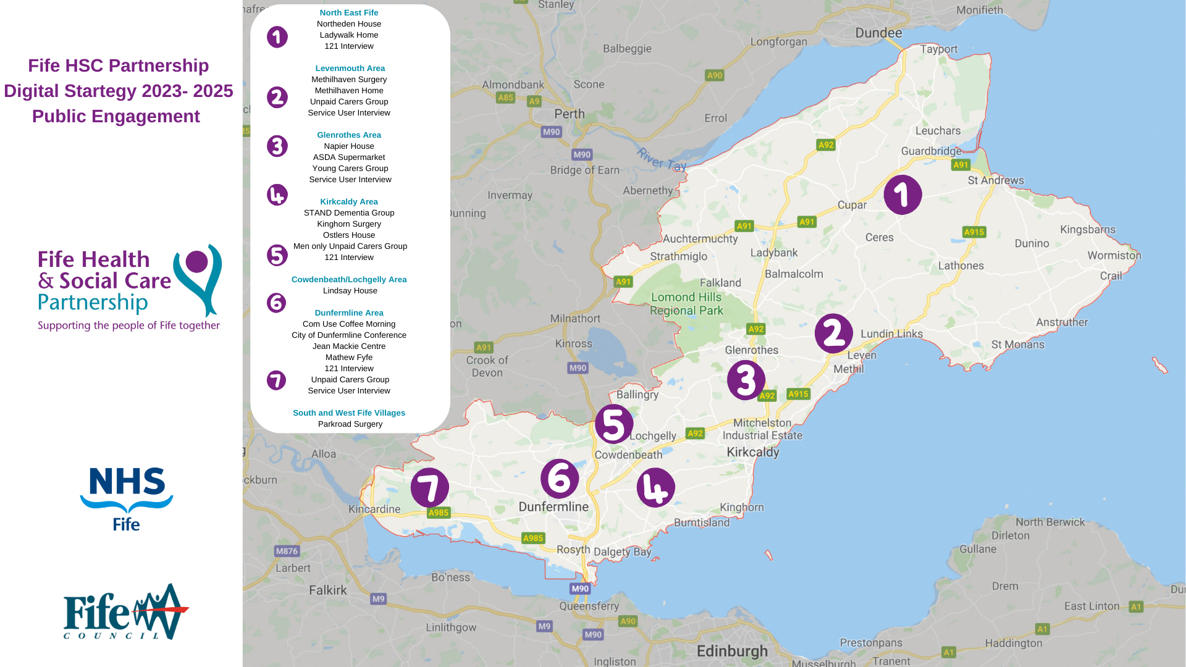

## **Appendix 2 Stories**

​

​

​

​